Contestant Number: ____________________
Time: ___________________
Rank: _______________


HEALTH INSURANCE & MEDICAL BILLING
(605)
NATIONAL 2024

CONCEPT KNOWLEDGE:

Multiple Choice (11 @ 5 points each) ________________ (55 points)

APPLICATION KNOWLEDGE:
Posting (10 @ 2 points each) ________________ (20 points)
Form Completion (25 @ 1 point each) ________________ (25 points)

TOTAL POINTS: ________________ (100 points)

Test Time: 60 minutes

GENERAL GUIDELINES:
Failure to adhere to any of the following rules will result in disqualification:
- Contestant must hand in this test booklet and all printouts, if any.
- No equipment, supplies, or materials other than those specified for this event are allowed in the testing area. No previous BPA tests and/or sample tests (handwritten, photocopied, or keyed) are allowed in the testing area.
- Electronic devices will be monitored according to ACT standards.

Multiple Choice Questions
Directions: Identify the letter of the choice that best completes the statement or answers the question.

- What part of Medicare is considered managed care?
  - Part A
  - Part B
  - Part C
  - Part D
- Insurance coverage obtained through a job is considered group insurance.
  - True
  - False
- Dr. Jones is a participating provider with Best Health Insurance. He receives $500 each month for each patient with Best Health Insurance. What is the name of this type of reimbursement method?
  - Fee-for-service
  - Capitation
  - Prospective payment system
  - Bundled payment
- Using the information below, determine the amount of reimbursement from the insuance company:
Deductible: $950 Deductible met: $715 Coinsurance: 25%
Procedure charge: $15,988.42 Procedure allowable: $10,651.75
  - $15,988.42
  - $7,812.56
  - $7,988.81
  - $10,651.75
- Using the information below, determine the amount of the patient’s responsibility:
Deductible: $950 Deductible met: $715 Coinsurance: 25%
Procedure charge: $15,988.42 Procedure allowable: $10,651.75
  - $2,662.94
  - $2,604.19
  - $2,839.19
  - $3,997.11
- When should a new patient be notified of the practice policy on collecting payment for services?
  - When the patient arrives for the appointment.
  - When checking the patient out after the appointment.
  - After insurance reimbursement has been received.
  - When the patient schedules the first appointment.
- HIPAA guidelines allow the patient to restrict use of their confidential information for payment purposes.
  - True
  - False
- What is the relationship of the amount of money owed to a healthcare organization and the amount collected on accounts receivable?
  - Account receivable report
  - Aging report
  - Collection ratio
  - Collection report
- “Your account is 90 days past due. Please remit payment.” is an example of a:
  - Dun message
  - Past due message
  - Payment demand message
  - Collection statement
- A claim with a humerus fracture diagnosis code and a radius fracture repair procedure code is denied. What is the reason for the denied?
  - The claim did not indicate left or right.
  - The date of service is not needed.
  - The procedure code is not required.
  - Lack of medical necessity.
- Medicaid is considered:
  - Primary insurance
  - Commercial insurance
  - Supplemental payer
  - Payer of last resort

Application Knowledge
Post the information on the remittance advice below to the appropriate ledgers on page 7.

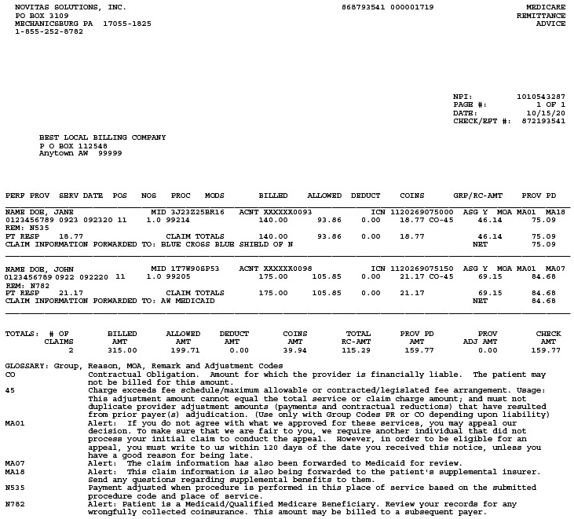

THIS PAGE LEFT INTENTIONALLY BLANK

Jane Doe
1145 NW Underwood
Anytown AW 99999
Date | Reference Number | Description | Charge | Payment | Adjustment | Balance
09/23/20xx | 99214 | Established patient office visit | 140.00 |  |  | 140.00

John Doe
657 West 87 Street South
Anytown AW 99999
Date | Reference Number | Description | Charge | Payment | Adjustment | Balance
09/22/20xx | 99205 | New patient office visit | 175.00 |  |  | 175.00

Use this encounter form to complete a CMS-1500 on page 10.
Janis Gross, MD (NPI: 5326587412)
Geriatric Specialists
758 East Grand Boulevard, Anyplace, ME 68469 657.437.1762
PATIENT INFORMATION |  | INSURANCE INFORMATION
Name: | John Johnson | Identification number: | 7ST4ZP0LZ2
Address: | 746 N Blaine ST | Group number:
City: | Anyplace | Primary Insurance Plan: | Medicare
State: | ME | Policyholder: | John Johnson
Zip Code: | 712987 | Policyholder date of birth: | 07/10/1925
Phone Number: | 657.216.7741 | Secondary Insurance Plan: | Medicaid
Date of Birth: | 07/10/1925 | Secondary Policyholder: | John Johnson
Gender: | Male | Policyholder date of birth: | 07/10/1925
Occupation: | Retired | Secondary Identification number: | 6512578365
Employer:
Employer Telephone:
Patient Status: ☐Married ☐Divorced ☐Single ☒Widowed
DIAGNOSIS INFORMATION
Diagnosis | Code | Diagnosis | Code
1. IBS w/o diarrhea | K58.9 | 2. Colon polyps | K63.5
PROCEDURE INFORMATION
Date of Service | Code | Description | Charge
1. 4/21/20XX | 45378 | Colonoscopy | 925.00
Referred by: Joan Reeder, MD NPI: 5841365478
Tax ID: 11-63258745 NPI: 6587423158 Place of Service: 22 Accept assignment: Yes
Procedure completed at: Cosper Hospital, 1234 West Canna Drive, Anyplace, ME 68469
NPI: 8521478523

